【系列】雅思A类小作文范文合辑（第一辑）
The chart below gives information about global sales of games software, CDs and DVD or video.
Write a report for a university lecturer describing the information.
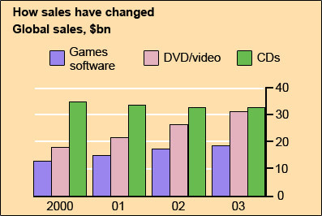
model answer:
The chart shows the changes in the sales of video material / DVDs, games software and CDs around the world in billions of dollars over a three-year period. It can be seen that the sales of videos / DVDs and games software have increased, while the sales of CDs have gone down slightly.
Between 2000 and 2003, the sale of videos and DVDs rose by approximately 13 billion dollars. In 2000, just under 20 billion dollars worth of these items were sold, but in 2003, this figure had risen to a little over 30 billion dollars.
The sales of games software also rose during this period, but less sharply. Sales increased from about 13 billion dollars in 2000 to just under 20 billion dollars three years later. By contrast, during the same time period, the sale of CDs fell from 35 billion dollars in 2000 to about 32.5 billion dollars in 2003.

Eating sweet foods produces acid in the mouth, which can cause tooth decay. (High acid levels are measured by low pH values)
Describe the information below and discuss the implications for dental health.
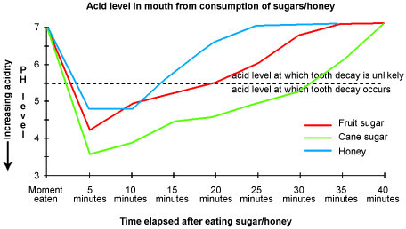
model answer:
Anyone who has visited a dentist has been told that eating excessive amounts of sweets risks harming the teeth. This is because sweets lower pH levels in the mouth to dangerous levels.
When the pH level in the mouth is kept above 5.5, acidity is such that teeth are unlikely to be in danger of decay. Sweet foods, however, cause pH in the mouth to drop for a time, and the longer pH levels remain below 5.5, the greater the opportunity for decay to occur.
By comparing fruit sugar, cane sugar and honey, which are all common ingredients of sweet foods, we find that cane sugar lowers pH levels for the longest period, thus producing the greatest risk of the three. Approximately five minutes aftfter consuming cane sugar, pH levels drop to as little as pH 3.5. They then begin to rise slowly, but do not rise above pH 5.5 until at least 30 minutes have elapsed. By contrast, fruit sugar, which causes the mouth's acidity to fall to just above pH 4, poses a danger for a shorter period: tooth decay is unlikely 20 minutes after consumption. Honey appears an even less risky substance. Though acidity falls to about pH 4.75 within five minutes of consumption, it returns to above pH 5.5 in under fifteen minutes.
The implications, then, are that people who insist on eating sweet foods should be aware of the ingredients, and that fruit sugar or honey appear preferable to cane sugar.

Write a report for a university lecturer describing the information in the two graphs below.
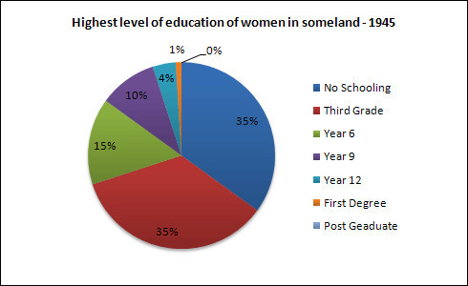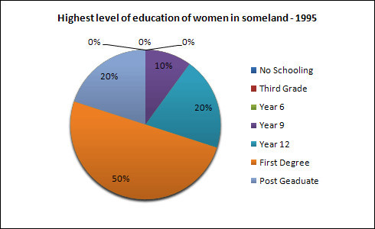
model answer:
The pie charts compare the highest level of education achieved by women in Someland across two years, 1945 and 1995. It can be clearly seen that women received a much higher level of education in Someland in 1995 than they did in 1945.
In 1945 only 30% of women completed their secondary education and 1% went on to a first degree. No women had completed post-graduate studies. This situation had changed radically by 1995. In 1995, 90% of women in Someland had completed secondary education and of those, half had graduated from an initial degree and 20% had gone on to postgraduate studies. At the other end of the scale we can see that by 1995 all girls were completing lower secondary, although 10% ended their schooling at this point. This is in stark contrast with 1945 when only 30% of girls completed primary school, 35% had no schooling at all and 35% only completed the third grade.
In conclusion, we can see that in the 50 years from 1945 to 1995 there have been huge positive developments to the education levels of women in Someland.

Write a report for a university lecturer describing the information in the table below.
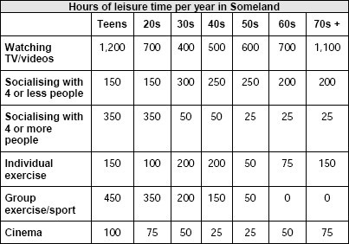
model answer:
The table shows how people in different age groups spend their leisure time in Someland over the course of a year. It can be clearly seen that the amount of leisure time available varies considerably across the age groups and that people of different age levels have very different ways of spending their leisure time.
According to the figures, as people age in Someland their social lives reduce. Teenagers and people in their twenties spend on average 500 hours per year on socialising and 350 hours of that time is with a group of more than 4 people. Although the total hours of socialising in their 30s, 40s, 50s and 60s is fairly constant (between 300-350), socialising with more than 4 people drops dramatically to 50 hours in the 30s and 40s age groups and only 25 from 50 years old. Group and individual exercise follow a similar pattern.
People of all ages spend a good part of their leisure time on entertainment such as TV/video viewing and cinema. In both cases, teenagers and retired people spend around twice as much time as those who are at working age. Home entertainment ranges from just over a thousand hours for teenagers and retired people and an average of 600 hours for everyone else. Cinema accounts for 100 hours of the teenagers and retired people’s leisure time and 25-50 hours for the rest.
In conclusion we can see there is a significant trend towards solitary and smaller group activities as people grow older and that teenagers and retired people spend a lot more time on entertainment than those of working age do.

The map below is of the town of Garlsdon. A new supermarket (S) is planned for the town. The map shows two possible sites for the supermarket.
Summarise the information by selecting and reporting the main features, and make comparisons where relevant.
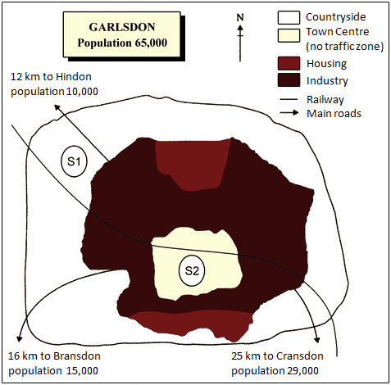
model answer:
The first potential location (S1) is outside the town itself, and is sited just off the main road to the town of Hindon, lying 12 kms to the north-west. This site is in the countryside and so would be able to accommodate a lot of car parking. This would make it accessable to shoppers from both Hindon and Garlsdon who could travel by car. As it is also close to the railway line linking the who towns to Cransdon (25 km to the south-east), a potentially large number of shoppers would also be able to travel by train.
In contrast, the suggested location, S2, is right in the town centre, which would be good for local residents. Theorically the store could be accessed by road or rail from the surrounding towns, including Bransdon, but as the central area is a no-traffic zone, cars would be unable to park and access would be difficult.
Overall, neither site is appropriate for all the towns, but for customers in Cransdon, Hindon and Garlsdon, the out-of-town site (S1) would probably offer more advantages.
The diagram below shows the typical stages of consumer goods manufacturing, including the process by which information is fed back to earlier stages to enable adjustment.
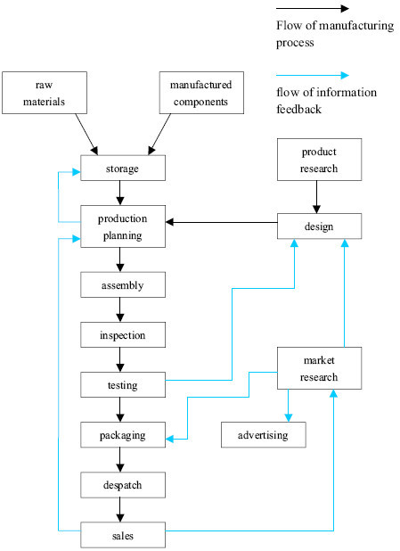

model answer:
Most consumer goods go through a series of stages before they emerge as finished products ready for sale.
Raw materials and manufactured components comprise the initial physical input in the manufacturing process. Once obtained, these are stored for later assembly. But assembly first depends upon the production planning stage, where it is decided how and in what quantities the stored materials will be processed to create sufficient quantities of finished goods. The production planning stage itself follows the requirements of the goods' design stage that proceeds from extensive research. After assembly, the products are inspected and tested to maintain quality control l Those units that pass the inspection and testing stages are then packaged, despatched and offered for sale in retail outlets. The level of sales, which is the end point of the manufacturing process, helps determine production planning.
A product's design is not only the result of product research, but is also influenced by testing and market research. If the testing stage (after assembly and inspection) reveals unacceptable problems in the finished product, then adjustments will have to be made to the product's design. Similarly, market research, which examines the extent and nature of the demand for products, has the role of guiding product design to suit consumer demands which may change with time. Market research, while influenced by product sales, also serves to foster future sales by devising suitable advertising for the goods.
Thus the reality of consumer goods manufacturing goes well beyond a simple linear production process.

【系列】雅思A类小作文范文合辑（第二辑）
The chart and graph below give information about sales and share prices for Coca-Cola.
Write a report for a university lecturer describing the information shown below.
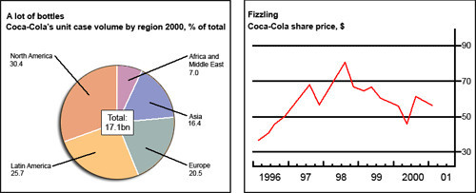
model answer:
The pie chart shows the worldwide distribution of sales of Coca-Cola in the year 2000 and the graph shows the change in share prices between 1996 and 2001.
In the year 2000, Coca-Cola sold a total of 17.1 billion cases of their fizzy drink product worldwide. The largest consumer was North America, where 30.4 per cent of the total volume was purchased. The second largest consumer was Latin America. Europe and Asia purchased 20.5 and 16.4 per cent of the total volume respectively, while Africa and the Middle East remained fairly small consumers at 7 per cent of the total volume of sales.
Since 1996, share prices for Coca-Cola have fluctuated. In that year, shares were valued at approximately $35. Between 1996 and 1997, however, prices rose significantly to $70 per share. They dipped a little in mid-1997 and then peaked at $80 per share in mid-98. From then until 2000 their value fell consistently but there was a slight rise in mid-2000.
The graphs below show the numbers of male and female workers in 1975 and 1995 in several employment sectors of the republic of Freedonia.
Write a report for a university teacher describing the information shown.
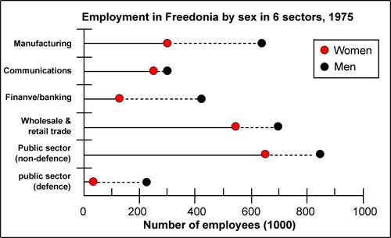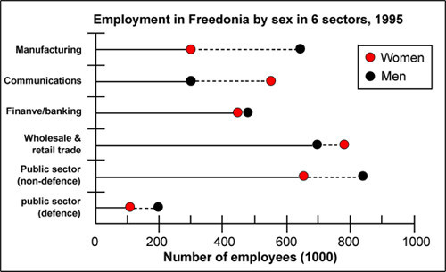
model answer:
The two decades between 1975 and 1995 brought significant changes in the representation of women in Freedonia's work force, according to the graphs.
In 1975, for example, some 300 000 men and 250 000 women worked in the communications sector. Twenty years later, though the number of men remained unchanged, the number of women rose to 550 000.
A similar situation was seen in the wholesale and retail trade sector, where the number of women rose from about 550 000 in 1975 to almost 800 000 two decades later. The number of men in this sector remained stable over the period, at around 700 000.
Women also made gains in both the finance/banking industries and in the defence-related public sector. Whereas some 125 000 women worked in finance and banking institutions in 1975, the number increased to 450 000 by 1995. The number of men grew only marginally from 425 000 to 480 000 over the same period. In defence, the number of men declined from 225 000 to 200 000, while the number of women rose from 25 000 to over 100 000.
Two sectors that retained stable employment numbers for both men and women were manufacturing, which had about 300 000 women and 650 000 men in both surveyed years, and the public sector (non-defence), which employed 650 000 women and 850 000 men.
Thus, women appear to have made gains in the Freedonian work force but not at the expense of men.

The table below shows social and economic indicators for four countries in 1994, according to United Nations statistics.
Describe the information shown below in your own words. What implications do the indicators have for the countries?
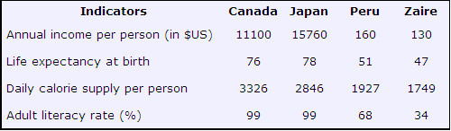
model answer:
A glance at four indicators of economic and social conditions in four countries, Canada, Japan, Peru and Zaire, in 1994 reflects the great differences that exist between wealthier and poorer nations.
The table shows that Japan and Canada had annual incomes of $15 760 and $11 100 per person, respectively. These figures were overwhelmingly greater than the corresponding figures of $160 in Peru and $130 in Zaire.
Health indicators, too, reflected overall levels of affluence in the four nations. Life expectancy at birth, for example, was higher among the more economically developed countries. Japan reported the highest life expectancy, 78. This was followed by Canada, 76; Peru, 51; and Zaire, 47; This suggests that richer societies are able to put more money into health care than poorer ones.
The amount of calories consumed daily per person roughly followed the same ranking. Canadians each consumed some 3 326 calories per day while the Japanese took 2846 calories. The corresponding figures for Peru and Zaire were 1927 and 1749, respectively.
Literacy rates among adults, too, were higher in wealthier countries, no doubt a reflection of ability to invest in education. Canada and Japan both reported literacy rates of 99%, while Peru claimed 68%. Zaire, the least economically developed of the four countries, had a literacy rate of 34%.
The data appear to confirm the often cited link between national wealth and health and education standards.
The diagram below shows the average hours of unpaid work per week done by people in different categories. (Unpaid work refers to such activities as childcare in the home, housework and gardening.)
Describe the information presented below, comparing results for men and women in the categories shown. Suggest reasons for what you see.
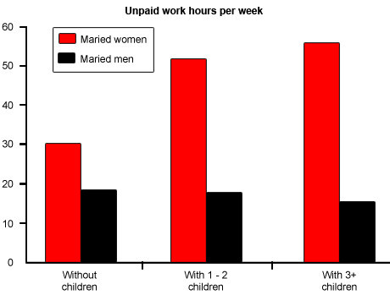
model answer:
The diagram reveals that the number of hours per week spent in unpaid work is unequally distributed between men and women.
In households where there are no children, women are reported to work some 30 hours per week in such tasks as housework and gardening. Men's contribution to these unpaid jobs averages a considerably lower 18 hours.
When children enter the household, however, the inequality becomes even more pronounced. In families of 1 - 2 children, men maintain approximately the same number of hours of unpaid work as in childless households, but the number of hours women work in the home rises to 52 per week, much of it, on doubt, due to childcare responsibilities.
Interestingly, when there are three or more children in the household, men are found to work even fewer hours around the house than before the appearance of the third child. Whereas women's unpaid hours rise to approximately 56 per week, the corresponding figure for men, 16, actually represents a decrease.
The data suggest that the increased presence of women in the paid work force has yet to lead to an increased role for men in the home.
Write a report for a university lecturer describing the information below.
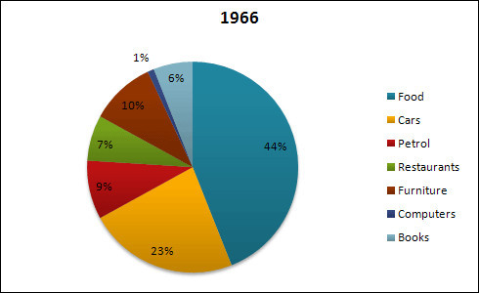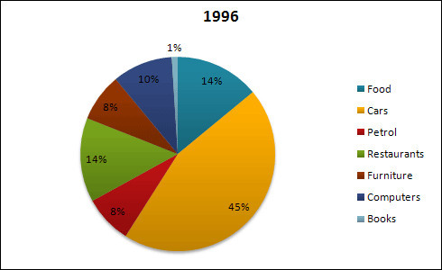
model answer:
The pie charts show changes in American spending patterns between 1966 and 1996.
Food and cars made up the two biggest items of expenditure in both years. Together they comprised over half of household spending. Food accounted for 44% of spending in 1966, but this dropped by two thirds to 14% in 1996. However, the outlay on cars doubled, rising from 23% in 1966 to 45% in 1996.
Other areas changed significantly. Spending on eating out doubled, climbing from 7% to 14%. The proportion of salary spent on computers increased dramatically, up from 1% in 1996 to 10% in 1996. However, as computer expenditure rose, the percentage of outlay on books plunged from 6% to 1%.
Some areas remained relatively unchanged. Americans spent approximately the same amount of salary on petrol and furniture in both years.
In conclusion, increased amounts spent on cars, computers, and eating out were made up for by drops in expenditure on food and books.
The table below shows the sales at a small restaurant in a downtown business district.
Summarize the information by selecting and reporting the main features, and make comparisons where relevant.
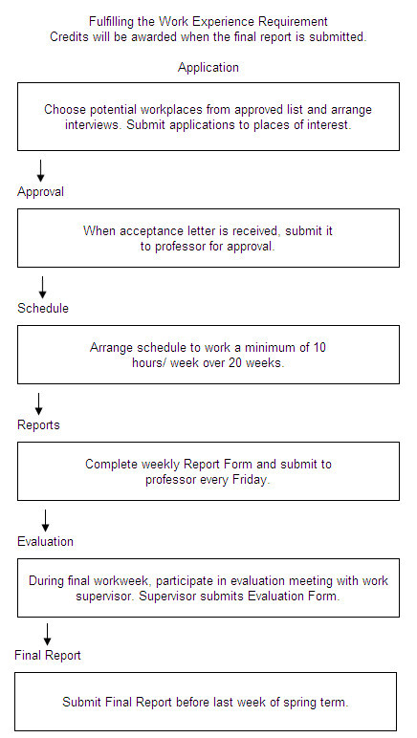
model answer:
Gaining work experience prior to graduation helps university students to succeed in getting their first job. For this reason, some universities insist that all students must complete a Work Experience Requirement. Completing the following six stages results in the requirements’ fulfillment.
The process begins with the Application stage. A student reviews an approved list of workplaces and submits applications to places where he would like to work. Next is the Approval stage. When a student receives an acceptance letter, he gives it to the professor for approval. The third stage, Schedule, requires a student to arrange his work schedule. The student should work at least 10 hours/week over 20 weeks. Reports are next. The student must complete a Weekly Report Form and turn it in to the professor every Friday.
The fifth stage, Evaluation, takes place during the final work week. A student participates in an evaluation meeting with his work supervisor, who submits an Evaluation Form. The last stage requires that a student submit a Final Report before the last week of spring semester.
By following these stages and subsequently submitting the final report, the student receives credit from the university.
The diagrams below give information about the Eiffel Tower in Paris and an outline project to extend it underground.
Write a report for a university lecturer describing the information shown.
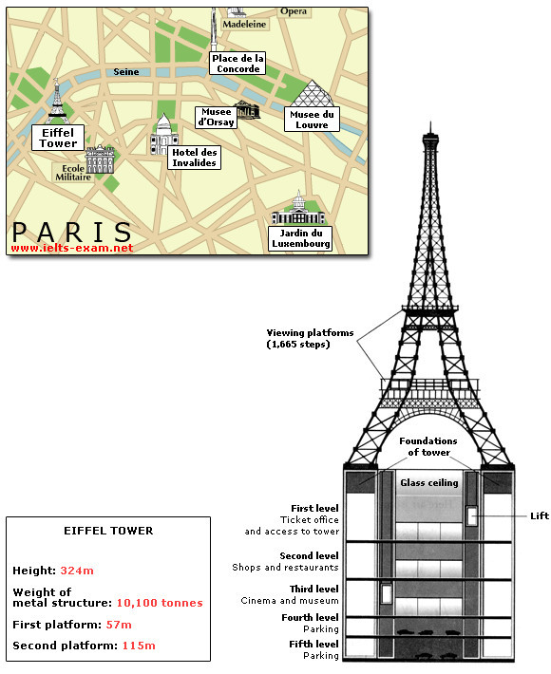
model answer:
The Eiffel Tower is situated close to the Seine River in Paris. It is a metal structure that is 1,063 feet high and weighs 7,417 tonnes. The tower has been a tourist attraction since 1889, when it was built, and there are 1,665 steps that can be climbed in order to reach the two viewing platforms.
There are now plans to build below the foundations of the tower. These plans include the development of five underground levels that will incorporate the tower's ticket office, shopping facilities, a cinema and museum and two floors of underground parking.
Although details have yet to be finalised, the principle is that the five floors will be connected by two vertical passenger lifts on either side of the tower. In addition, the floor immediately below the tower, which is planned to house the ticket office, will also consist of a large atrium with a glass ceiling so that visitors can look directly up at the tower itself.

资料--流程图+地图
流程图6点参考要领：
1. 找到流程图的过程，起点，终点。
2. 找到图上标出的已知动作，如果出现生词，尽量猜测。无词，用自己的语言。
3. 按照步骤，分段描述，千万不能省略任何一步。
4. 切记!加入流畅合理的表示顺序的关联词。
5. 句型以主动为主，搭配被动，以及主语从句(例如：It can be seen from the graph that…)。
6. 时态要使用一般现在时。
例文分析1：
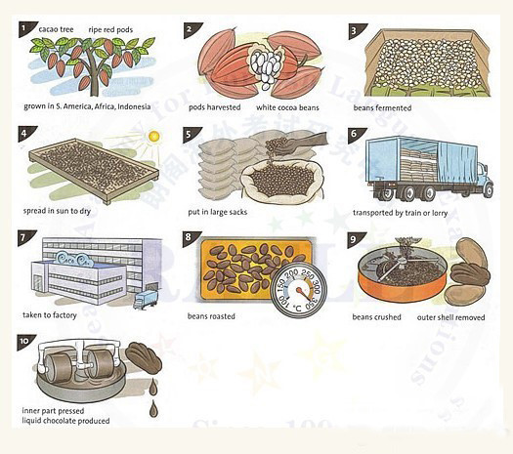
The diagram shows the stages in the process of making chocolate.(所有的小作文第一句话都要用一般现在时。流程图必备三个词：process整个过程;stage阶段;step步骤)
Chocolate comes from the cacao tree, which is grown in parts of South America, Africa and Indonesia.(开头不能一上来就直接介绍cacao tree,而是通过主题词chocolate引出，否则显得太唐突)【流程图特点之一：介绍过程要使用一般现在时】【流程图特点之二：大量使用定语从句，将有关联的两句话连接。】【流程图特点之三：大量使用被动语态】The tree produces large red pods which contain white cocoa beans.【流程图特点之四：使用一些表示顺序的连接词】when the pods are ripe, they are harvested, the beans are removed and they are fermented for several days in large wooden boxes.(三个句子的并列：“句子A,句子B and 句子C”。)During the fermenting process, the beans turn brown.【流程图特点之五：要适当地添加个别图中没有交代但能从图片中直接读出来的一些内容，否则可能达不到字数要求。但是一定要把握尺度，千万不要加上自己的主观观点，否则会扣分】
Next, the brown beans are spread in the sun to dry. They are then put in large sacks and transported by train or lorry. After this, the beans are taken to a chocolate factory where they are roasted in an oven at temperatures of between 250 and 350 degree Celsius.
After being roasted, the beans are crushed and the outer shell is removed. This part is not needed for making chocolate. Finally, the inner part of the bean is pressed and liquid chocolate is produced.【流程图特点之六：一般不需要写总结】
例文分析2：
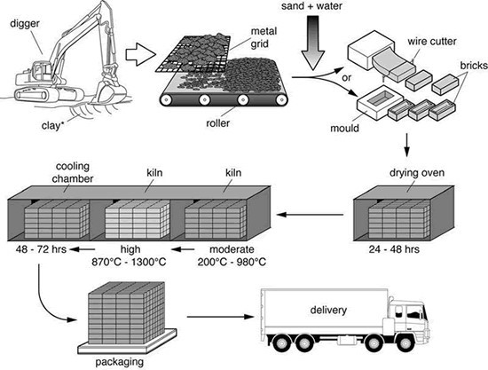
The process by which bricks are manufactured for the building industry can be outlined in seven consecutive steps. First the raw material, clay, which was just below the surface of soil in certain clay-rich areas has to be dug up by a digger.
Then the lumps of clay are placed on a metal grid in order to break up the big chunks of clay into much smaller areas, which fall through the metal grid onto a roller, whose motion further segregates the bits of clay. Sand and water are added to make a homogenous mixture, which is then either formed in moulds or cut into brick-shaped pieces by means of a wire cutter.
Those fresh bricks are then kept in a drying oven for at least 24 and a maximum of 48 hours, several dozens if not hundreds of bricks at a time. The dried bricks are then transferred to a so-called kiln, another type of high temperature oven. First they are kept at a moderate temperature of 200 ℃ -1300 ℃. This process is followed by cooling down the finished bricks for 48 to 72 hours in a cooling chamber.
Once the bricks have cooled down and have become hard, they get packaged and delivered to their final destination, be it a building site or storage.
(215 words)
【考官评语】
Band 9
This response fully satisfies the requirements of the task. All key features of each stage of the process are appropriately and accurately presented. An excellent overview is given at the beginning of the response and this skilfully incorporates part of the rubric, changing the grammatical function, to give a brief summary of the whole process. The message is very easy to read, with seamless cohesion that attracts no attention. Paragraphing, linking and referencing are all skilfully managed. The language used is very fluent and sophisticated. A wide range of vocabulary and structures are used with full flexibility and accuracy. Only rare minor ‘slips’ can be found and these do not detract from the high rating.
例文分析3：
下面是剑桥6的test 3 考到的流程图，考官给的范文。范文中有两步考官直接就写成一步，
本来是3-8天和16天两个时间段，缩成了3个星期，大家写的时候可以分别写，不用写这
么精练。范文：
The first diagram shows that there are four main stages in the life of the silkworm.
第一个图显示了，在蚕的生命过程中主要有四步。First of all, eggs are produced by the
moth and it takes ten days for each egg to become a silkworm larva that feeds on
mulberry leaves. 首先，蛾子产出卵，每个卵用10天的时间变成蚕的幼虫， 他们以桑叶
为食。This stage lasts for up to six weeks until the larva produces a cocoon of silk
thread around itself. 这个阶段持续最多到六个星期，直到幼虫周围生产出茧（silk
thread）. After a period of about three weeks, the adult moths eventually emerge
from these cocoons and the life cycle begins again. 经过三个星期的一段时间之后，
成年的蛾子最终从茧里面出来，这个生命的循环就再一次开始了。
The cocoons are the raw material used for the production of silk cloth. 茧是生产
丝绸的原材料。Once selected, they are boiled in water and the thread can be separated
in the unwinding stage. 一旦被挑选出来，他们在水里煮沸，丝可以在打开的阶段中被分
离出来。Each thread is between 300 and 900 metres long, which means they can be twisted together, dyed and then used to produce cloth in the weaving stage. 每条丝是300
到900米长，这就意味着，他们能够被缠绕在一起，染色，然后在织布阶段被用于生产布品。
Overall, the diagrams show that the cocoon stage of the silk worm can be used to
produce silk cloth through a very simple process.
范文总结：
1． 163个字。
2． 使用了很多合适的关联词，见阴影部分。
3． 主要是简单的并列句。
4． 句型，搭配了一些被动语态。
5． 动词使用丰富：produce, feed on, last, emerge, select, boil, separate, unwind,
twist (多数原词带入)
6． 名词比较专业：life cycle, raw material.
雅思流程图的重点词汇解析：
表述时间：
in 10 days
during the period of 10 days
The process lasts for up to 10 days
after 10 days
10 days passed until something happened.
表示然后：then, next, in the next state, following that, after that, the next step in the stage is ....
表示过程：process, procedure, formation, development
表示步骤：step, stage, phase
时间阶段：after a period of …months/days/minutes, during…
顺序连词：first, first of all, in the first stage, initially, to begin with
second, then, next, also
after that, at the same time, in the meantime, meanwhile
prior to, until
the first stage involves … / in the second stage / in the third stage /
in the last stage / The next step in the stage is that…
目的连词：in order to / in order that; so as to / so that
常见动词：
produce生产，lay放置，accumulate积累，gather/collect收集，obtain获得，heat up加热，expand膨胀，bend弯曲，turn off关闭，cool down冷却，disconnect断开连接，spin旋转/纺，strike打击， compress压缩，release释放， expand膨胀， move/flow流动， accelerate加速， form形成， press按压， adjust调整， absorb吸收， form形成， process加工， rotate旋转， chop坎， grind磨(碎)/碾(碎)，light点燃， burn燃烧， ignite点燃， reflect反光，turn转，starts开始， stops结束，records录音， turns up调高， turns down调低，winds缠绕, unwinds解开，revolves旋转，fold折叠，unfold打开，reverse颠倒/倒转，adapt适应，adjust调整，alter改变，cure治愈，disappear消失，dissolve溶化/解散，exchange交换，expand扩张/膨胀，fade退色，increase增长，promote促进/升职, reduce减少，renew使更新/使恢复，renovate革新/更新/修复，replace取代，swell肿胀，switch改变，transform完全改变，vary改变，swap交换，shrink收缩，melt溶解，heal/cure治愈，form/come into being/take shape形成，produce生产，gain/get/acquire获取，evaporate蒸发，volatilize挥发，draw提取，recycle回收，extract拔，absorb吸收，collect收集，meet相遇，be made up of由...组成, be made of由...制成，be made from由…制成， feed on以...为食，depend on/rely on依赖，release/send out释放，sort分类，separate分开，conveyed运送，cut into切成，poured into倒入，heated加热，melted into融化成，flows into流入
----------------------------------分 割 线----------------------------
地图
地图题写作在很多书上都没有系统的指导，它有别于数据图，构思方面没有数据图那么复杂，但在语言驾驭，很多学生都感到很陌生。
地图题分两种，一种为地理变迁题，一种为选址题。首先我们来看地理变迁题，它描述的是一个地方（多为一个城镇）在一段时间的发展变化。如2006年9月A 类 TASK 1， 剑1TEST 4。就这些图形，我们来总结地理变迁题的写作要点。
地图题注意要点：
1 .地图的起始点
2 .方向很重要
3 .认真阅读并尽量记住图中已有的信息
考察点：
1 .方向方位路线顺序的把握
2 .相对位置关系的描述和辨别
3 .表方位的词或者词组主要是介词的用法
4 .图中关键词的定位
î 时态
如果地图题反映的是一个地方在过去的一段时间的变化，文章用一般过去时。如果地图题反映的是一个地方在将来一段时间的变化趋势，文章用一般将来时或表“估计”的词汇。如果地图题反映的是一个地方从过去到现在的变化，可用现完成时。
如：现在停车场改成了一个剧院。
The car park has been removed and replaced by a theatre.
城镇A的家庭数量从1937年到2020年将翻一番。
The number of homes in Town A is likely to double
(is likely to= is predicted to /is estimated to/is projected to/is expected to )
又可为：
It is likely that the number of homes in Town A will double.
(it is likely that = it is predicted/estimated/projected/ expected that…..)
1．读题：读图标的含义，哪个是铁路，哪个是村庄等等都读明白了。要看清哪个是公路，哪个是铁路。有没有交叉点等等。
2．确定写的顺序，是按变化写还是按位置写，还是两个的综合体。
3．如果是要求描述变化，把明显的变化先划出，最好用词在图旁边描述，确定
自己要写几点。
4．句型多用被动语态。
5．时态使用一般现在时或者过去时,也可能现在完成时。表示将来的时间可以用
下列表达：be predicted/be expected to do…
一般不用将来时，用上面的结构。
6．记得用关联的词和句子：
It is obvious/notable/noticeable
It is easy to locate/to find that…
It can be seen from the graph that…
地图题最好的补充资料就是听力题里面的地图题的单词
î 细节变化
地图每个细节变化都要提到，不要忽视一个细节
î 语态
地图题用被动语态
如： 2000年在城镇A 新建了一个医院：A new hospital was established in Town A in 2000.
î 地图题的书写顺序：时间顺序和空间顺序
如2006年9月A 类TASK 1
The map shows the development of the village of Kelsbey between 1780 and 2000.
这篇文章大体框架按时间顺序，BODY 分三段分别描述：1780年村庄，1860村庄， 2000年村庄。对每一年的描述，如1780年村庄，我们要注意按方位顺序来描述，否则文章会出现混乱。这就需要考生在考前对方位词进行总结。地图题的方位我们说东西南北，不说成左右。
î A 在B 的东方/西方/南方/北方
A is/ lies/ is located/ is situated in/on / to the east/west/south/north of B
(in 表A 在B 内部， ON 表A 和B接壤，TO 表A 和B 分开)
î A 在B 内部的某个部位
A is in the eastern/ southern/ western/ northern part of B.
î A在B 西北部的120 千米处
A lies 120 km to the northwest of B.
î A 在B…..角落
A is at/in the south-eastern corner of B ( at 表示A 在B 外部， in表A 在B 内部)
î 在河流或道路的南边/北边等
On the south/southern side of the river
On both sides of the road
On the other side
î 临近马路的地区
The area adjacent to/ near /next to/ just off the road
î 在道路或河流的最南端
At the southern end of the river
î A 在B 的对面
A is on the opposite side of B
A is opposite B
î A 在B 东部的边界上（A 在B外部）
A is on the eastern border of B
î A 在B 东部边缘上 （A 在B 内部）
A is on/ along the eastern edge of B
î “变化”词汇
地图题描述的是一个地区的变化，那么“变化”词汇必须过关。
变化包括两种：图形原有事物的改变，图形新添事物。
我们先看图形原有事物的改变：
î 原有事物可说成：
The original/previous/former garden
î 原有事物尺寸上变大/变小：
The size of the library has been enlarged/extended/halved/reduced by half
î 原有事物在数量上增多或减少：
The number of homes has increased/risen/grown/reduced /decreased/dropped/fallen/
doubled/ tripled/ quadrupled to 500.
î 原有事物没了：
The farms completely disappeared/were removed.
î 原有事物被改为：
A becomes B
A is transformed/reconstructed/redeveloped/converted/changed/turned over to/ into B
A is replaced /substituted by B = A gives way to B
î 图形新添事物
A newly-built road
A new car park was built/established/set up/constructed/completed and opened in the middle of B
A new IT centre has been added to the library
The year 2000 saw two additions to the land: a pond in the northern part and a vegetable garden on the opposite side.
地图题第二类为选址题 如剑5 TEST 3 TASK 1
The map shows two possible sites for the supermarket. 为一个城镇的超市选址， 有两个位置 S1 和S2 供选择。选址题并不难写，主要注意两点：
î 位置描述
î 优缺点
这篇文章我们BODY段可分两段，分别陈述：
S1的位置及位置相应的优缺点
S2的位置及位置相应的优缺点
其中表位置的方位词已在前文有总结，
同理， 2006 年2 月A 类Task 1: The diagram below shows the problem of flooding in a UK town and two possible solutions
我们BODY 段可分两段，分别陈述：
Solution 1 的解决方案和相应的优缺点
Solution 2 的解决方案和相应的优缺点
其中，解决方案实际还是要涉及一些方位词。
总之，对于地理变迁题，建议考生考前要充分的掌握上述五点，勤加练习，选址题则把握位置和优缺点两个要害，地图题的写作就会明朗化。

地图题在雅思小作文写作中可以说考的频次非常低，顶多一年一次而已。纵观历次雅思地图题写作，我们不难发现无非就是“两位置方案的二选一或“某处事物新旧变迁的过程描述”。不管“二选一”还是“过程描述”，请注意，一定不要忘了要结合地图中所体现的“人文与地理环境”进行相互的“比较与对比”且体现“比对结果”；而这里的比对，前者是“横向比对”，强调各自“优缺点比对”，后者则是“纵向比对”，强调“新旧变化”。解题思路有了，那么剩下的是语言上的事情了。
在语言上，请你注意以下几个方面：首先平时要多积累表示“方位、比对、变化”等方面的词汇和句子表达；其次，要注意时态的选择，“二选一”型常用一般现在时态，而“过程描述”型则要视题目而定，往往综合运用一般过去时态、一般现在时态和现在完成时态；最后，要注意语态的把握，要主动与被动相互结合运用，记住适当被动能给考官好印象，但切忌出现人称代词。
大作文：
重点预测题：
1、 It is not necessary for people to travel to other places to learn about the culture. We can learn as much as from books, films and the Internet. To what extent do you agree or disagree?
2、Some people think government money spent on supporting artists (such as painters, musicians and poets) is better than that spent on other important things. To what extent do you agree or disagree?
3、 Nuclear energy is better than other energy resources in meeting ever-increasing needs of the globe. To what extent do you agree or disagree?
4、Some people think that governments should do more to make their citizens eat a healthy diet. Others, however, believe that individuals must take responsibility for their own diet and health. Discuss both these views and give your own opinion.
5、 Some people think sports games are important for society, while others believe they should more be taken as leisure activities. Discuss.
6、Some people think that environmental problems are too big for individuals to solve. Others, however, believe that these problems cannot be solved if individuals do not take actions. Discuss both these views and give your own opinion.//The international community must act immediately to ensure that all countries reduce their consumption of fossil fuels, such as gas and oil. To what extent do you agree or disagree?
7、Some people think the university education function should prepare the students for employment ,but others believe university education can offer many other functions .Discuss both views and give your own opinion.
8、 Some people think reading stories in books is better than watching TV or playing computer games for children. To what extend do you agree or disagree?
9、 Some people think that students in single-sex schools perform better academically. Others, however, believe that mixed schools provide children with better social skills for adult life. Discuss both these views and give your own opinion.
10、 Some people think that the main purpose of schools is to teach children to be a good citizen or worker rather than to benefit them as individuals. To what extent do you agree or disagree?
11、 There are many advertisements which are directed at children, such as snacks, toys and other goods. Parents argue that they will impose negative influence to their children. But the advertisers claim that advertisements provide some useful information to children. Discuss the both viewpoints and give your own opinion.
12、 Air travel and telecommunication makes the communication all over the world closer. To what extent do you agree that the society benefits from international tourism and business?
13、Some people say that there is a need to recycle the items that we throw away every day, what are the reasons and what individuals can do?
14、 In some countries, many children are unhappy. What are the reasons? What can parents and schools do to solve this problem?
15、Some people say that teaching the young generations foreign languages is the best way to broaden their visions about the world. To what extent do you agree or disagree? （1.7欧洲考了是否应该在小学教授外语）
15、Computers enable people to be able to work at home and children to study at home. Some people believe that it is convenient and cost-saving. Do you think the phenomenon positive or negative?
16、Some people say that governments should spend money on measures to save languages that are used by few speakers, while others believe it's a waste of financial resources. Discuss both views and give your opinion.
17、These days young adults are encouraged to work for a period of time after high school, however, others think they should continue to study. Discuss both views and give your opinion.
18、 Some people think that robots are very important for humans' future development. Others, however, think that robots are a dangerous invention that could have negative effects on society. Discuss both views and give your opinion.
19、Some people believe that the subjects and lesson contents should be decided by the authorities such as the government. Some people argue that teachers should make the choice. Discuss the both viewpoints and give your opinion.（1.9新增）
19、 Some children think that some subjects such as mathematics and philosophy are too difficult for them to study at school, so they should be made optional rather than compulsory. To what extent do you agree or disagree? （1.7国内A类大作文考了艺术是否应该是必修课）
20、The increasing demand for oil and gas has made it necessary to look for these sources of energy in remote and untouched natural places. Do you think the advantages of locating oil and gas in these areas outweigh the disadvantages of deranging these places?
21、The workplace nowadays is trying to employ the equal number of females and males. Do you think it is a positive or negative trend?
22、 The costs of medical health care are increasing all the time. Governments are finding it difficult to balance the health care budget. So citizens should be totally responsible for their own health costs. Do you agree or disagree? （1.9变更）
23、 Some people think that parents have a great influence on their children, others believe that the media is a bigger influence. Discuss both views and give your opinion.
24、 More and more people want to study at university, so competition of university places is increasing. Why do more people want to study at university? Is it positive or negative?
25、Some people think governments should protect local companies when they compete with international companies. Do the advantages outweigh the disadvantages?
26、Government funding for universities should only be provided to the best students as scholarship and all other funding for universities should come from tuition fees and private organizations. To what extent do you agree or disagree?
27、 Countries with a long average working time are more economically successful than those countries which do not have a long working time. To what extent do you agree or disagree?//Some countries have a long working day, which is helpful for them to become economically successful, but it also causes some negative social problems. To what extent do you agree or disagree?
28、Some people believe that government should help and look after old people, but others believe that people should save money for their lives in the future. Discuss both views and give your opinion.
29、 In the past, cultural and historical relics were stored in museums. But now, people can see them freely with the internet. Some people believe that museums are no longer needed in the future. To what extent do you agree or disagree?
30、 Some people think that education should help students to be useful to the whole society, while other people think that education should provide students with opportunities to achieve personal ambitions. Discuss both views and give your own opinion.
31、More and more people choose online shopping. Some people think this trend will have positive influence (such as creating new jobs), however others think it causes many problems. Discuss both views and give your opinion.
31、 Today, the qualities of life of people in big cities are worse. What are the causes of this problem? Any measures should be taken to solve it?
32、Some people think that maintaining public libraries is waste of time because computer technologies have already replaced its function. Do you agree or disagree?
33、 Some people argue that it is better to be unemployed than to be employed in jobs they do not enjoy. To what extent do you agree or disagree?
33、 Some people think individuals are more and more dependent on each other. Some people think individuals are more and more independent. Discuss both views and give your own opinion.
34、 Many young people leave school with a negative attitude. What are the reasons? What can be done to encourage young people to study with a positive attitude?
35、 Some people say that history can teach us many important values and lessons, but others think it is unnecessary to learn from the past. Discuss both views and give your own opinion.
36、Many fathers today stay at home and take care of their children while mothers go out to work. What are the causes of this? Is this a positive or a negative development?
37、Some people believe the best way to upgrade social security is to allow people to own weapons like guns. To what extent do you agree or disagree?
38、Some people think that criminals should not be imprisoned. Instead, education and job training should replace the former to deal with criminals. To what extent do you agree or disagree? To what extent do you agree or disagree?
39、 It is more important for a building to serve a purpose than to look beautiful. Architects shouldn't worry about producing building as a work of art. Do you agree or disagree?
次重点预测题：
1、Some people believe that in order to reduce crime, prisoners should be given longer prison sentence while some people think there are other alternative ways. Discuss the both viewpoints and give your opinion.
2、Young people are often influenced in their behaviors and situations by others in the same age. This is called “peer pressure". Do the disadvantages outweigh the advantages?
3、 Some animal species such as dinosaurs and dodos become extinct because of natural processes. So, it is not necessary to try and prevent this from happening. Do you agree or disagree?
4、Many people in community now could buy consumer goods being cheaper，whether the advantages outweigh the disadvantages？
5、 Nowadays the trend of human beings to copy from one another is shown in the popularity of fashion in clothes and other consumer goods. To what extend do you agree or disagree?
6、Governments should spend money on the repairs and maintenance of old buildings. To what extent do you agree or disagree?
6、 Animal testing has been an important part of scientific research, but some people suggest that it's less practical and it will cause extreme pains to the animals so we should stop doing it, do you agree or disagree?
7、 More and more people are moving from rural areas to cities in search of a better life, but city life has its own problems. What are these problems? Suggest some solutions. \\A rise in the standard of living in a country seems to only benefits cities rather than rural areas. What problems might this difference cause? How might the problems be reduced?
8、 In some countries boarding schools are getting more popular. Is it a positive or negative development? What are the reasons behind it?
9、 Some people believe that students at schools and universities can learn more from teachers than from the internet. To what extent do you agree or disagree?
10、 Some believe advertisement is useful and informative. Others think it is false and only helps to raise prices. Discuss both views and give your opinion.
11、 Some people think that universities should accept equal numbers of male and female students in every subject. To what extent do you agree or disagree?
12、The leaders or directors of organizations are often older people. But some people say that young people can also be a leader. To what extent do you agree or disagree?
12、 Today, more and more people use mobile phones. Do you think the benefits of mobile phones outweigh the drawbacks?
13、 Some people think male leaders always lead us to violence and conflict, but female leaders are better than male leaders to give us the better governed and more peaceful society. Do you agree or disagree？
14、 Some people think traveling abroad is a valuable experience for young people. Others think it wastes too much time and expense. Discuss both views and give your opinion.
15、 Professional workers like doctors, nurses and teachers make a greater contribution to society and so should be paid more than sports and entertainment personalities. To what extent do you agree or disagree?
16、 Some people think we should keep all the money we earn and not pay tax to the state. To what extent do you agree or disagree? // Some people think paying taxes should be voluntary instead of compulsory. Do you agree or disagree?
17、 Some people say that playing computer games is bad for children in every way. Others say that playing computer games can have positive effects on the way children develop.
18．An increasing number of people change careers in their working life. What are the causes?Do you think it has a positive or negative effect on the development of society?
19、Some people believe the range of technology available to individuals today is increasing the gap between poor people and rich people. Others think it is having an opposite effect. Discuss these points of view. What is your opinion?
20、In many countries, average life expectancy has been increasing. What problems will this cause for individuals and for society as a whole? Suggest some solutions.
21、Some people believe that to maintain the cultural identity of a city, the government should build all the new buildings in a traditional way, to what extent do you agree or disagree?
22、 The exposure of international media such as films, TV and magazines has impacts on local culture. What do you think of the impacts have been? Do you agree that the advantages outweigh the disadvantages?
23、 Many parents go to work in other countries, taking their families with them, do you think the advantages overweigh the disadvantage.
24、 Some people think that the increasing use of computers and mobile phones for communication has a negative effect on young people's reading and writing skills. Do you agree or disagree?（1.9变更）
24、Universities and colleges are now offering qualifications through distance learning from the Internet rather than teachers in the classroom. Do you think the advantages of this development overweigh the disadvantages? (命中1.7澳洲A类大作文)
25、 Today, fewer elderly people live with their children than in the past. Do you think this is a positive or a negative development?
26、 Some people believe that students should study in groups while others that they should study independently. Discuss the both ways and give your own opinion.
27、Some people think that adults should learn practical skills by themselves, while others believe that learning from a teacher in a classroom is better. Discuss both these views and give your own opinion.
28、 It is now possible for scientists and tourists to travel to the outer space. Do the advantages outweigh the disadvantages?
29、Lifestyles and culture in many countries is becoming similar，is it positive or negative?//The major cities in the world are growing fast, as well as their problems.What are the problems that young people living in cities are faced with? Give some solutions to these problems.
30 、Some people believe that the government should encourage the business and industries moving from large cities into regional areas. Do you think the advantages outweigh the disadvantages?
31、In some countries, the rate of crimes committed by teenagers is increasing. What are the reasons and what can be done to relieve the problem?
32、New technologies have changed the way people spend their free time. Do you think the advantages outweigh the disadvantages? //Nowadays more and more people have consumer goods, such as refrigerator or washing machines. Do you think this development has more advantages than its disadvantages?
33、 Consumers are faced with increasing numbers of advertisements from competing companies. To what extent do you think are consumers influenced by advertisements? What measures can be taken to protect them?
2017年1-4月命中记录（未改变原题序号）：
15、Some people say that teaching the young generations foreign languages is the best way to broaden their visions about the world. To what extent do you agree or disagree? （1.7欧洲考了是否应该在小学教授外语）
19、 Some children think that some subjects such as mathematics and philosophy are too difficult for them to study at school, so they should be made optional rather than compulsory. To what extent do you agree or disagree? （1.7国内A类大作文考了艺术是否应该是必修课）
24、Universities and colleges are now offering qualifications through distance learning from the Internet rather than teachers in the classroom. Do you think the advantages of this development overweigh the disadvantages? (命中1.7澳洲A类大作文)
2016年9-12月命中记录（未改变原题序号）：
32、 Many countries are trying to improve the standard of living of their people through economic development. However, some people think that traditional values are lost as a result of this. To what extent do you agree or disagree with this opinion?（9.10国内考了是否应该保留传统习俗和行为）
6、Governments should spend money on the repairs and maintenance of old buildings. To what extent do you agree or disagree?(近似命中9.24 北美A类大作文原题)
1、 Some people claim that public museums and art galleries will not be needed because people can see historical objects and works of art by using a computer. Do you agree or disagree with this opinion?（10.8国内A类考了电脑是否该取代图书馆）
21、Some people think that men and women have different qualities. Therefore, some certain jobs
are suitable for men and some jobs are suitable for women. To what extent do you agree or disagree?（10.8原题命中澳洲A类大作文）
2、Detailed descriptions of crimes in the news media、movies and TV programs should be strictly controlled. To what extent do you agree or disagree? (10.10变更) （基本命中10.22国内雅思A类大作文）
8、 Some people think that governments in developing countries should introduce new technologies to people in order to improve the quality of life, while others believe that in order to achieve that governments should offer free education for all. Discuss both these views and give your own opinion. （澳洲10.22雅思A类大作文考了关于政府是否应该提供免费教育）
21、Today, many people prefer to buy goods made in other countries, what are the reasons? What influences will this cause? (近似命中10.29澳洲A类大作文原题)
32、 Many countries are trying to improve the standard of living of their people through economic development. However, some people think that traditional values are lost as a result of this. To what extent do you agree or disagree with this opinion?（10.29 澳洲G类考了传统文化丧失的原因）
33、 Some people think individuals are more and more dependent on each other. some people think individuals are more and more independent. Discuss both views and give your own opinion.（原题命中11.5国内A类大作文）
31、 Today, the qualities of life of people in big cities are worse. What are the causes of this problem? Any measures should be taken to solve it?（近似命中11.3国内A类大作文、11.5澳洲A类大作文）
32、In order to solve traffic jam and air pollution, governments should promote the use of bicyles and restrict vehicles. To what extent do you agree or disagree? （10.31新增）（近似命中11.5北美A类大作文）
12、 As countries develop, their populations tend to live individually or in small family units. In your opinion, what is this cause and what are the effects on society. \\In many countries today, people in cities either live alone or in small family units, rather than in large, extended family groups. Is this a positive or negative trend?(命中11.19国内A类大作文)
25、 Some people think news has no connection to people's lives, so it is a waste of time to read the news on the newspaper and watch television news programs. To what extent do you agree or disagree?//Some people take newspapers to be the most effective way to get information, while others believe the best way to learn news is from other media. Discuss both views and give your opinion.（近似命中11.19澳洲A类大作文）
20、 Some people think that the increasing use of computers and mobile phones for communication has a negative effect on young people's reading and writing skills. Do you agree or disagree?（近似命中德国11.26A类大作文）
12、 More and more people rely on mobile phones and computers for long-distance communication. Some people believe that the traditional skill of letter writing will disappear completely. To what extent do you agree or disagree?//Today, more and more people use mobile phones. Do you think the benefits of mobile phones outweigh the drawbacks?（国内11.26考了手机影响人面对面交流的能力）
24、 Consumers are faced with increasing numbers of advertisements from competing companies. To what extent do you think are consumers influenced by advertisements? What measures can be taken to protect them?//Advertising encourage people to buy in quantity rather than promoting its quality. To what extent do you agree or disagree?(11.21补充) (命中11.26澳洲A类大作文)
26、 Some people think the public facilites like parks and libraries should be charged for all visitors.To what extent do you agree or disagree?(10.31新增)（12.3国内A类考了政府只为运动员修建专用场馆）
27、 Some people think that national teams and individual men and women should be financially supported by government. However others argue that national teams and individual men and women should be funded by non-government sources (business, companies). Discuss both of the views and give your own opinion. （12.3国内A类考了政府只为运动员修建专用场馆）
38、 Some people think they have right to use as much natural resources as they want, others believe government should control the use. Discuss both views and give your opinion.(11.7更新) （近似命中12.10国内A类大作文）
14、 Some people think traveling abroad is a valuable experience for young people. Othersthink it wastes too much time and expense. Discuss both views and give your opinion.// It is thought that people who travel outside of their own country are more tolerant and understanding of others. To what extent do you agree?(10.24补充)（近似命中12.10澳洲A类大作文）
2、 Many people believe that scientific research should be carried out and controlled by the governments rather than private companies. To what extent do you agree or disagree with this opinion? (11.28变更)（原题命中12.10英国A类大作文原题！）
17、 Some people say that playing computer games is bad for children in every way. Others say that playing computer games can have positive effects on the way children develop. (11.28新增) （近似命中12.17澳洲A类大作文）

